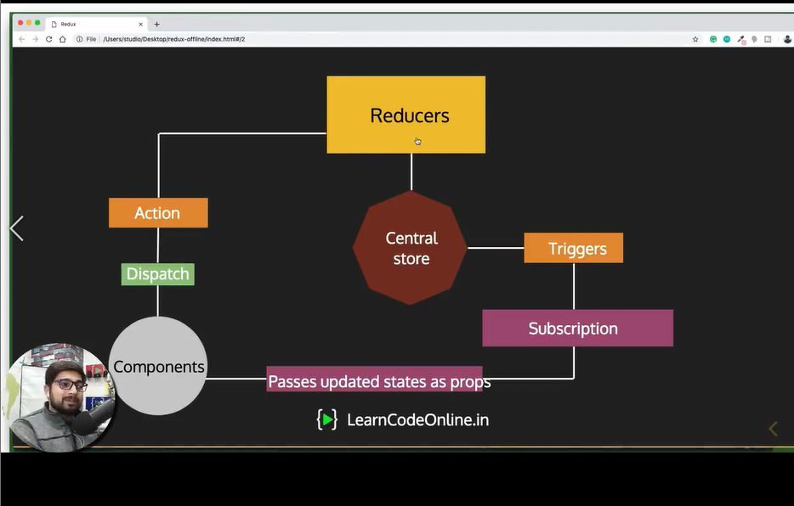

States or Data is to be stored in a single place

States are read only

Changes are made with pure functions

Central states, Store, Actions, Reducers, data Flow